Todos los Miembros de SSC

San Ferando Middle School
Elecciones de Funcionarios
Del Comité SSC

(Consejo del Plantel Educativo)
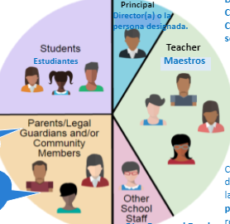

lunes, septiembre 22 del 2020
Hora: 3:30 pm

ID: 860 1134 1739
Passcode: team
Link: https://lausd.zoom.us/j/86011341739

Call all SSC Members

San Fernando Middle School
SSC Officer Elections

(School Site Council)

Monday, September 22, 2020
Time: 3:30 pm
ID: 860 1134 1739
Passcode: team

Link: https://lausd.zoom.us/j/86011341739

